Installation Guide:

Lerryn eShopCONNECT for Connected Business

Version 2.0

www.pluginsforconnectedbusiness.com

Lerryn eShopCONNECT for Connected Business Installation Guide

This is a guide for installing the Lerryn eShopCONNECT for Connected Business product and its Activation once installed.

eShopCONNECT consists of a plugin for Connected Business, which provides the main configuration options for eShopCONNECT, a Web Service module which accepts XML import data posted from external Web Sites and a Windows Service which performs all the automated and scheduled tasks for eShopCONNECT.

Starting with Connected Business 13.1, eShopCONNECT is included as an installer option. The eShopCONNECT plugin is already registered, but the Windows and Web services are not installed by default.

To install the eShopCONNECT Windows and Web Services, please run Connected Business installer by selecting Programs and Features in Windows Control Panel, then select the Connected Business entry in the installed programs list and click the Change button.

When the Connected Business installer opens, select Modify Available Options and click Next.

On the Features List, scroll down to find the eShopCONNECT features and make sure both the Web Service Component and Windows Service Component are selected for installation

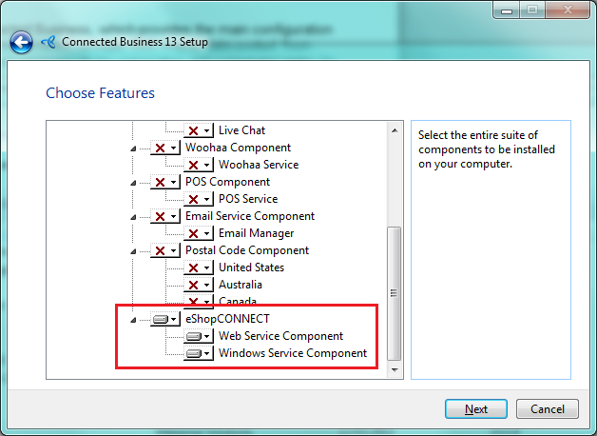

Then click Next as necessary to complete the installation

Like most Lerryn plugins for Connected Business, eShopCONNECT requires Activation before it can be used. Please see the ‘Activation Guide for eShopCONNECT for Connected Business.pdf’ document that is installed with Connected Business for details

